**CATABE**

**Members:** Catienza, Tarquini, Besana

Tsek is a checklist app that offers users a way to organize their tasks and assist in time management with the use of one application.

**Requirements**  
  
* Location - In order for the app to correctly calculate the time, the app will require the user to turn on Location for determining the current time zone of the user.  
* Internet Connection - This is required for syncing data with your other mobile devices, and for account linking.

**Design Space**

The internet connection required for the sync feature may be hard to realize due to the complexities of cloud storage, and the fact that this application is meant to track the deadlines of tasks.

We considered a feature that could allow users to sync their LMS to Tsek like an extension, however, it seems too unlikely for this to work. Another possible issue we could encounter with

What requirements may be difficult to realize?

What are some tradeoffs that you should or did explore?

Which tasks will be easiest to support? Which are the hardest?

**Design Summary**

These are the alternative designs that we had created before ultimately choosing the final one. We had agreed that some just weren’t very creative or eye-catching, while others were either too messy or tacky to look at, particularly draft 3 of the “CTB” logo, which looks like it’s just been mashed together. For the “Tsek” logo, we chose the first draft because the alternative looked too simple and doesn’t properly convey what the app is supposed to be.

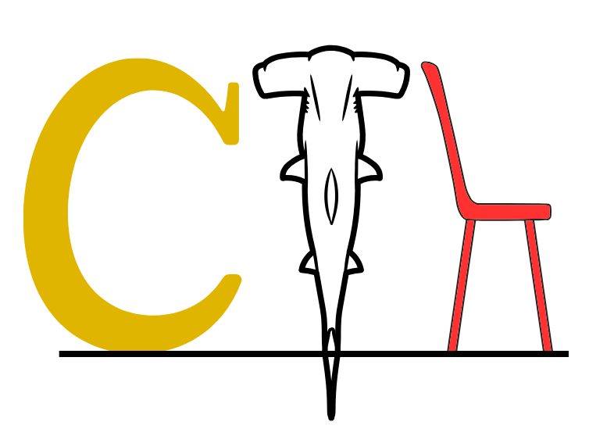

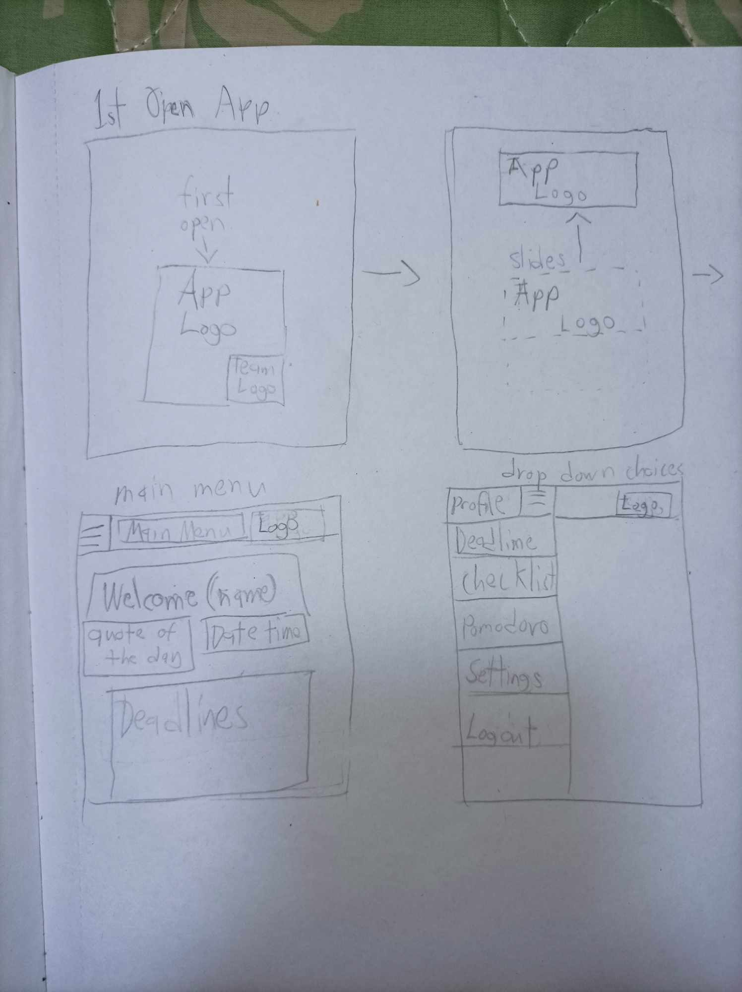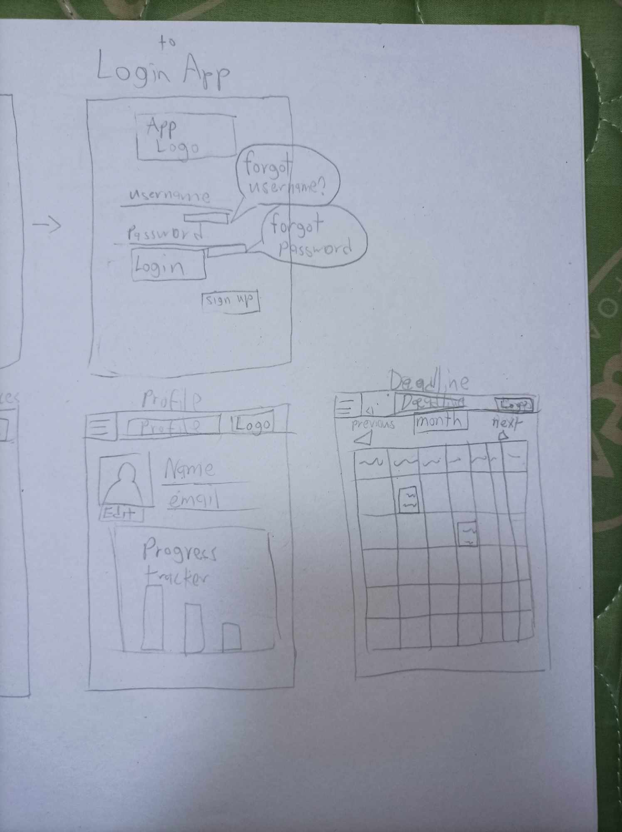

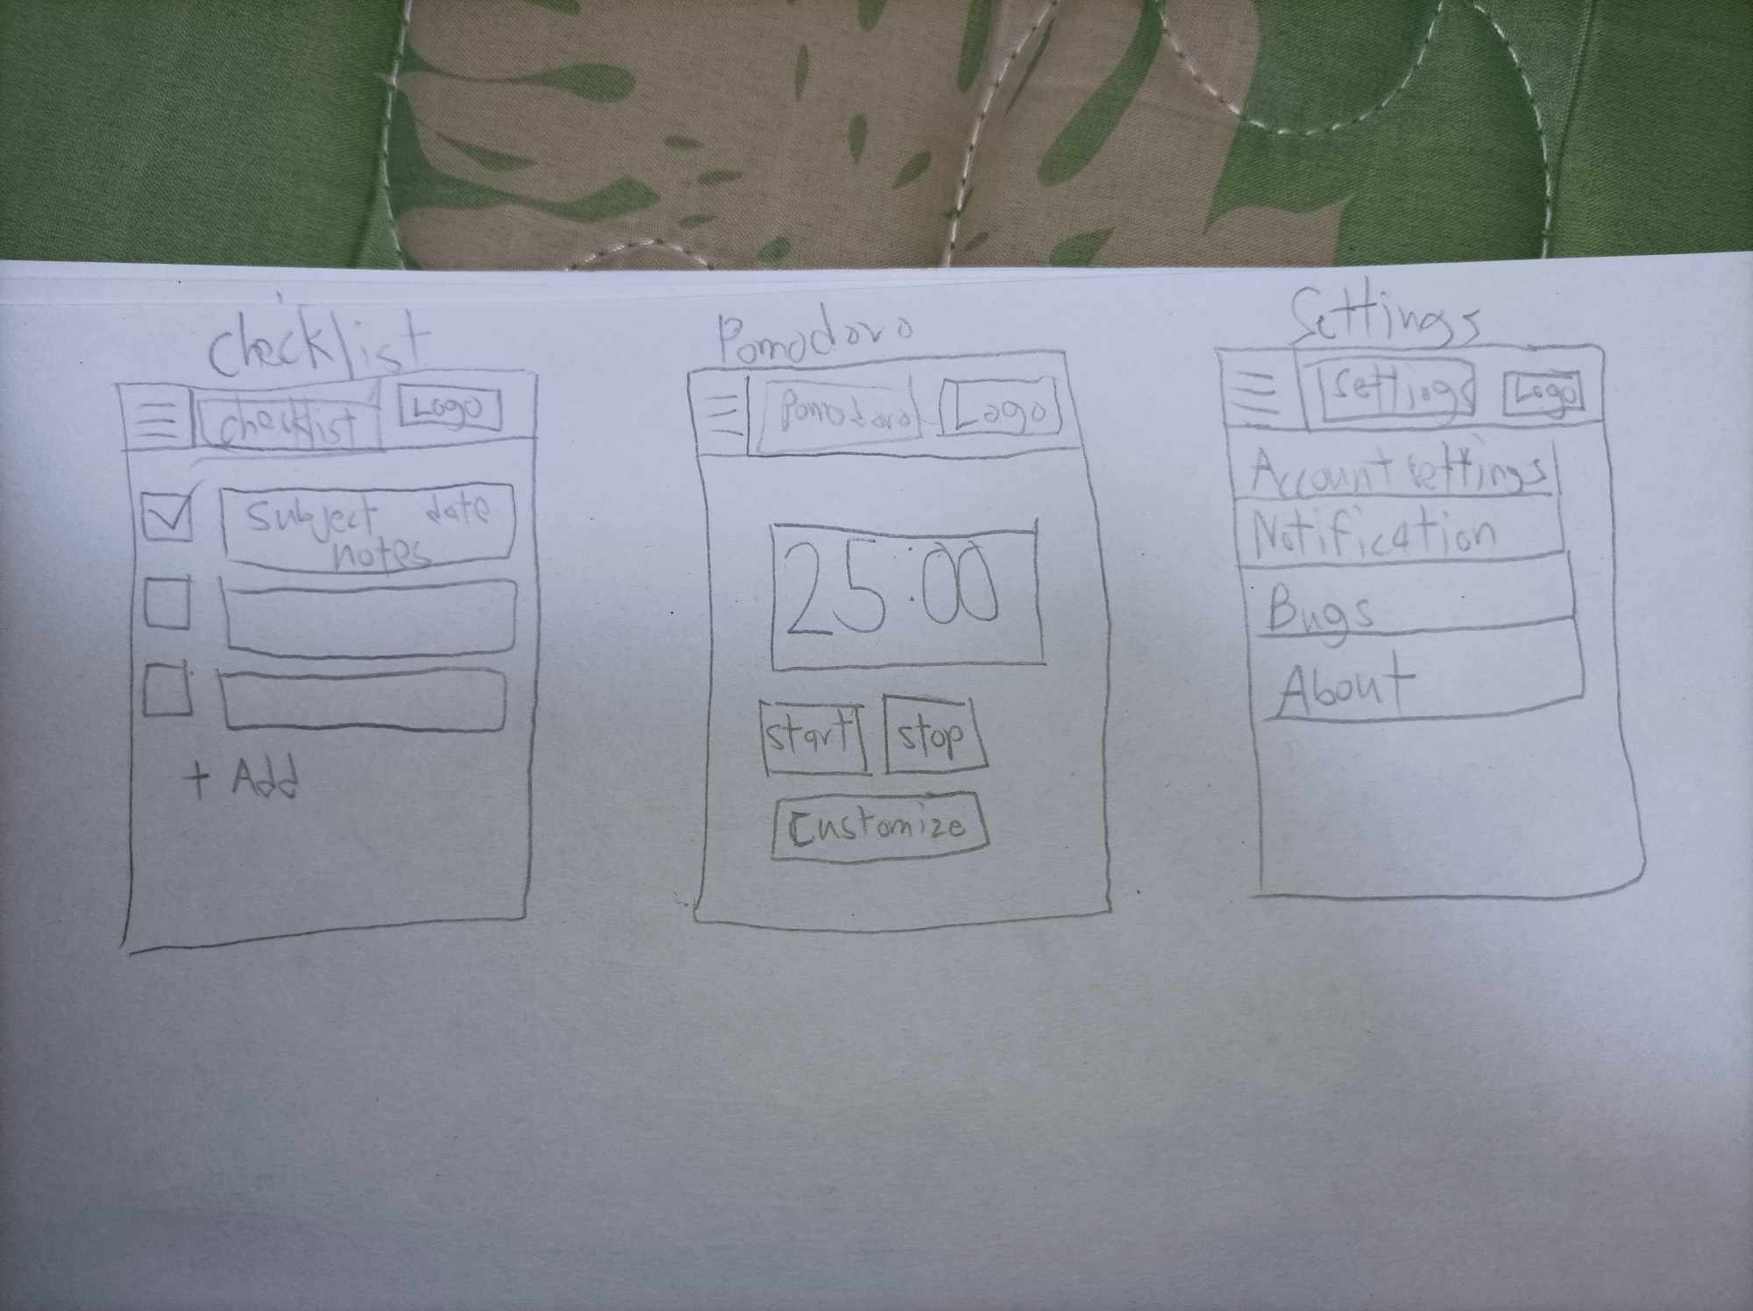  
These prototypes are very similar to the final outcome, and are only different with some smaller details and such.



**This is the opening screen when the application is opened for the first instance, and contains the logo of the application and the developer’s logo. It serves as a quick way to launch the application to the next part.**

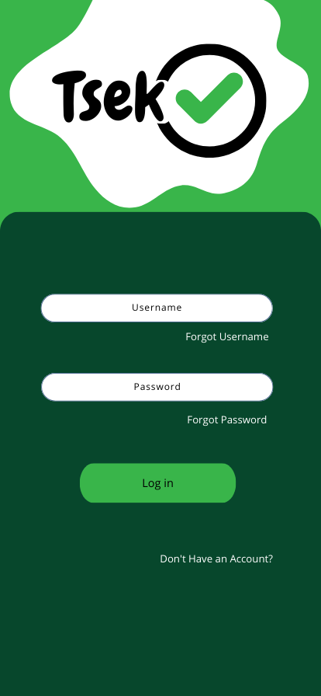

**If the user of the app has not logged in to their account or does not have one yet, this will be shown as the initial process of using the application. There are options that will aid the user if they have forgotten their username or password and have a sign-up button to make a new one.**

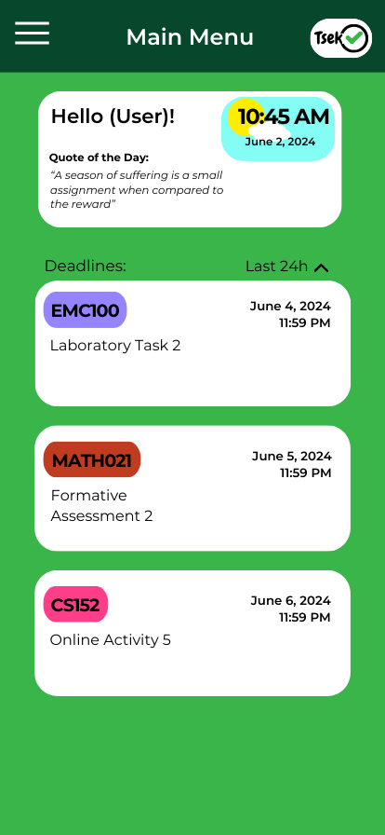

**This is the Main Menu screen, this is where the users will see after the initial process such as the login screen. This is also the screen that is used for those who are already logged in prior. The main menu greets the user with their name, a clock that shows the time and date that has a background that corresponds to the time, and a quote that changes every day to keep the user motivated. The logo and the name of the area is shown at the top area, alongside the collapsible button. The main menu also shows a simple view of the deadlines, which can be sorted by time.**

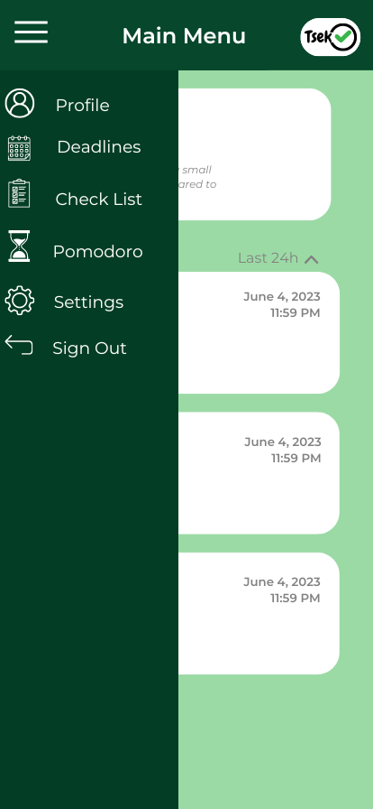

**The collapsible button shows the other parts of the application, which include the profile, deadlines, checklist, Pomodoro, settings, and a sign-out button.**

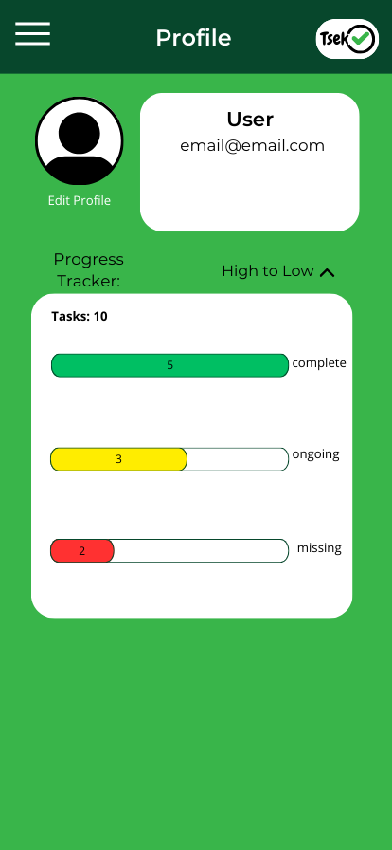

**The Profile shows the information that is crucial to the progress of the user. It has the picture, name, and active email that is being used. It can also be edited with the edit profile underneath the profile picture. The progress tracker shows the tasks amount of tasks added to the application and shows which ones are completed, ongoing, and are missed.**

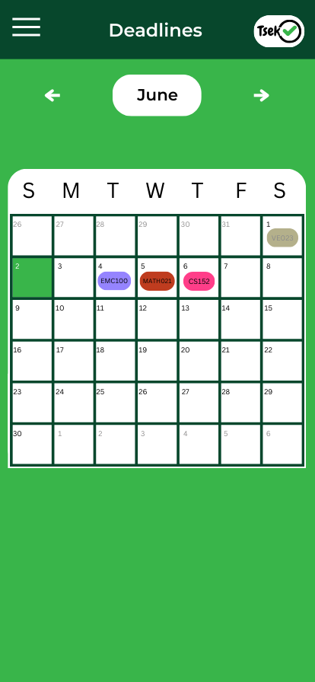

**The Deadlines shows a calendar with the current month but it also can check the previous and the upcoming months. The green tile shows the current date which helps indicate how near or how far a task is if a task that was already done previously or in advance will be semi-transparent to help the user identify which was done or not.**

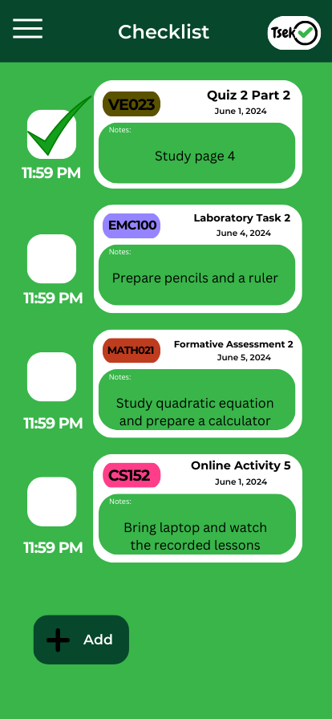

**The Checklist shows the task that have been added and marks them if they are completed by the user, information such as the name of the subject, name of the task, date, and notes that the user can add as a self-reminder with that task.**

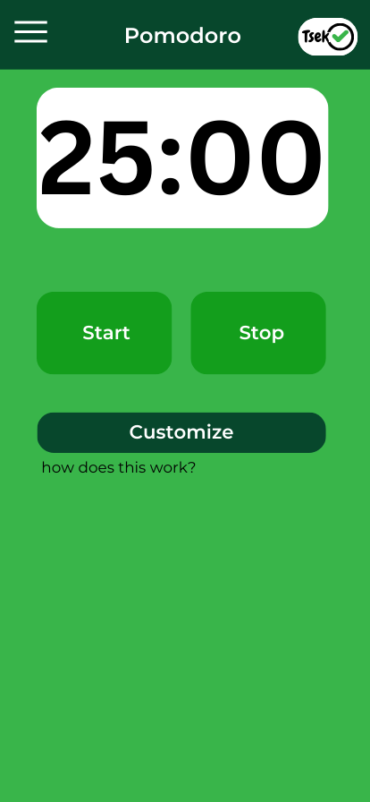

**The Pomodoro timer helps the user to manage their time when doing their task. The default time is 25 minutes to do the task and 5 minutes break. A start and stop button is used to initiate and halt the operation of the Pomodoro timer. A customize button is also added to let the user choose their preferred time.**

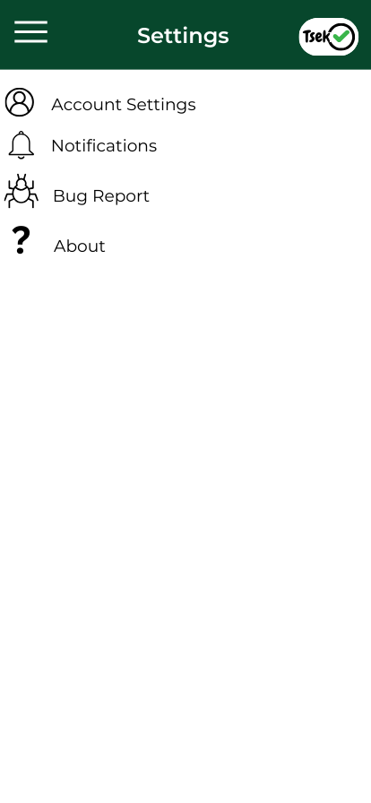

**The settings button shows the basic redirections to things like the account settings for setting up the account like the password, to even deleting the account itself, notifications for the reminders of the application to the user, bug reports for the user to inquire about an issue with the application and the about for the application version, developer information and so on.**